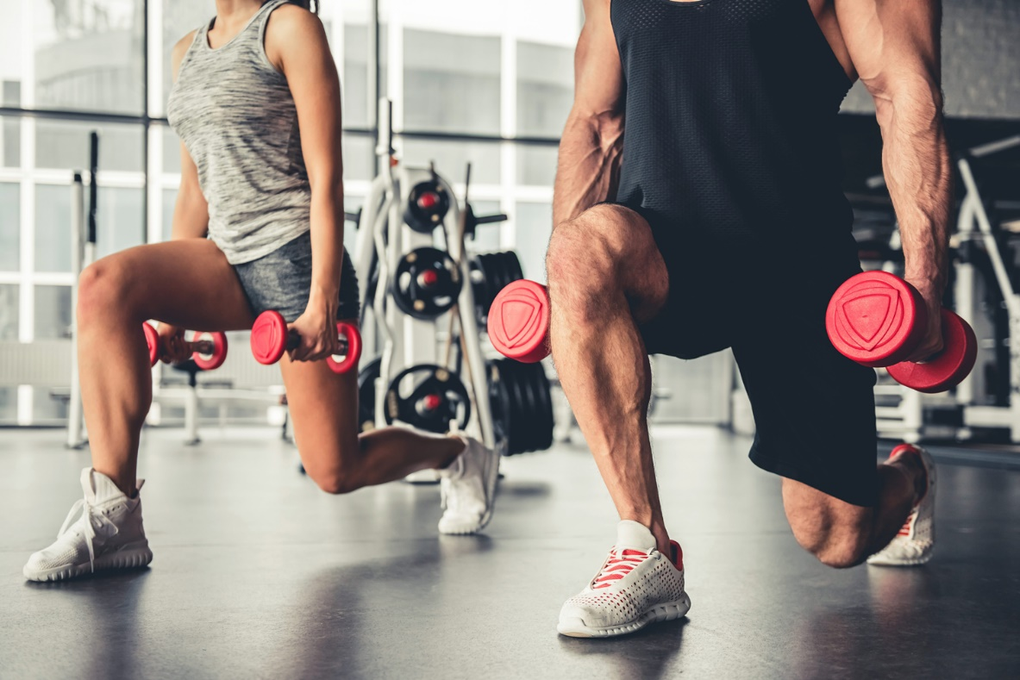
Visit us at www.globalhealthy.example!

Our Story
Over 25 years ago, we opened the first Bit by Bit Fitness center in Hartford, Connecticut. It wasn’t fancy; it didn’t have a pool or a sauna. It didn’t have a spa room or vibrating massage chairs. No TVs. No magazines.
What it did have: a sociable and welcoming atmosphere. A nonjudgmental approach to fitness. State-of-the-art exercise equipment. And a pledges to help you be the best you can be.
That little gym was the start of something very big: a passionate tradition of providing fitness opportunities to everyone—and we mean everyone. Now, 25 years later, Bit by Bit Fitness has expanded to 14 fitness centers in 3 states: Connecticut, New York, and Vermont.

Why Choose Us?
We believe that regular exercise benefits everybody. We believe that it’s never too soon—and it’s never too late—to start improving your quality of life. No matter what your resent level of fitness is, we’ll help you make it better.
Want to improve your mobility, flexibility, and strength?
Want to make new friends, learn Zumba, or join in fitness challenges with others?
Wish you could play with your kids (or grandkids) more?
Looking to improve your overall well-being and self-confidence?

What We Offer
- Cardiovascular Equipment: Our cardio room has it all and then some: treadmills, elliptical and arc trainers, recumbent and upright bicycles, and much more!
- Strength Training Equipment: Get stronger! We offer Cybex and Nautilus machines, and a fully outfitted free weights area.
- Group Fitness Classes: Our group fitness classes offer invigorating and fun workouts. Dance to the oldies, learn to Zumba, practice group strength training, or wind down with a gentle yoga session, all in our dedicated fitness studio.
- Personal Training: Our personal trainers are certified exercise specialists, and can help you get the results you want. Sign up for one session or a package, and get workouts designed just for you!
- Bite by Bite Café: After your workout, relax with a fruit smoothie or a cup of one of our herbal teas. Replenish your energy with a healthy meal from our menu of soups, salads, and sandwich wraps.
- Community Room/Library: A Bit by Bit Fitness exclusive! Because we think a gym should be more than a collection of bikes and barbells, we provide a comfortable space for members to hold meetings, listen to lectures, and use the materials in our health and fitness library. The Community Room is also available to rent for special occasions.

The Bit by Bit Golden Rules of Fitness

- Move more. It doesn’t matter what you do; just move, every day! Garden, walk, jitterbug around the house. Climb more stairs. Swing your arms. Jump on one of our fabulous cardio machines.
- Eat better. Less fast food, more slow food. Cook your own food—it’s the only way to know what’s in it!
- Lift things. Your toddler. Your dog. The barbells and plates in our free weights area. Strength training helps you build lean muscle and burn more fat.
- Exercise with a friend. Find one at Bit by Bit Fitness!

Become a Member Today!
Membership Level | Single | Family
Day Pass | $5 | n/a
Monthly | $30 | $45
Yearly | $300 | $450
Questions?
1-800-555-7000. Or globalhealthy@hotmail.com

